Assignment -1
Module -1
Q1. What is SDLC
A1. SDLC means the process of designing testing software development life cycle.

Q2. What is software testing?
A2. Software testing is a process of correctness, completeness and quality of developed computer software.

Q3. What is agile methodology?
A3. Agile SDLC model is a combination of iterative, incremental process .

Q4. What is SRS
A4. SRS is a software requirement specification it is complete , description , behaviour of the system to be developed.

Q5. What is oops
A5. OOPS means object oriented programming language is one which easily supports object-orientation programms.

Q6. Write Basic Concepts of oops
- Class
- Object
- Inheritance
- Encapsulation
- Polymorphism
- Abstraction

Q7. What is object
A7. Object is a represents an individual, identifiable item it is a object.

Q8. What is class
A8. Class is a define a blueprint for an object .

Q9. What is encapsulation
A9. Encapsulation is a one object to hide other object.

Q10. What is inheritance
A10. Inheritance means one class inherits the characteristics of another class.

Q11. What is polymorphism
A11. Polymorphism means “having many forms”.

Q12. Draw Use case on online bill payment system (paytm)
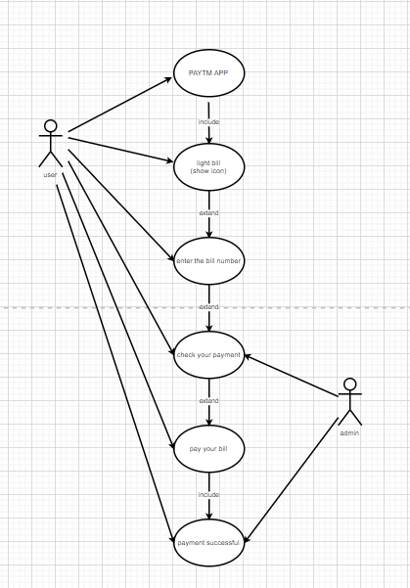

Q13. Draw Use case on banking system for customers.
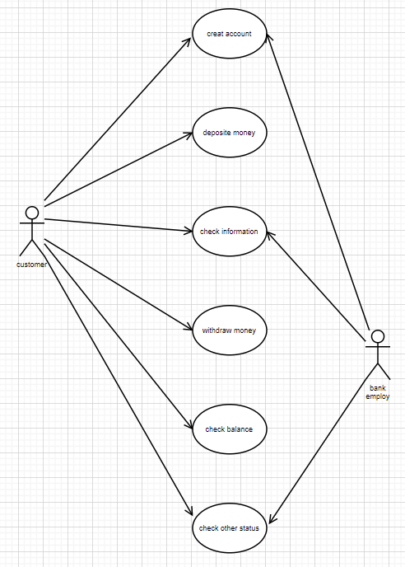

Q14. Draw Use case on Broadcasting System.
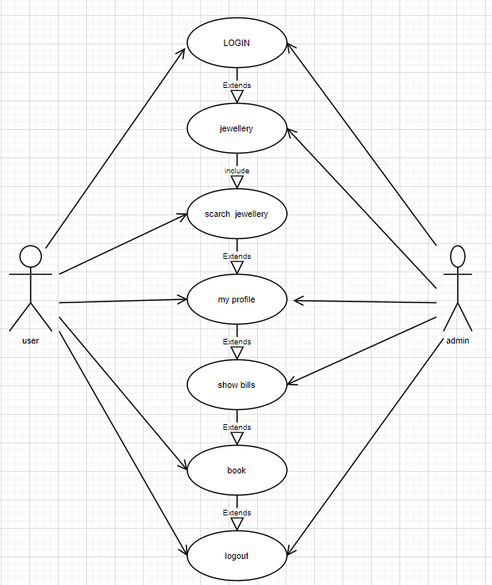

Q15. Write SDLC phases with basic introduction
- Requirement gathering and analysis
- Designing
- Implementation
- Testing
- Deployment
- Maintenance

Q16. Explain Phases of the waterfall model
A16. There are six phases
- Reguirements collection
- Analysis
- Design
- Implementation
- Testing
- maintenance

Q17. Write phases of spiral model
A17. There are four phases
- planning
- risk analysis
- customer evaluation
- engineering

Q18. Write agile manifesto principles

Q19. Explain working methodology of agile model and also write pros and cons.
A19. Agile methodology means delivering working software is small part with continuous feedback and improvement.
Pros
- continuous feedback
- continuous improvement
- fast delivering
- daily meeting
- work divided in small parts

Q20. Draw usecase on OTT Platform.
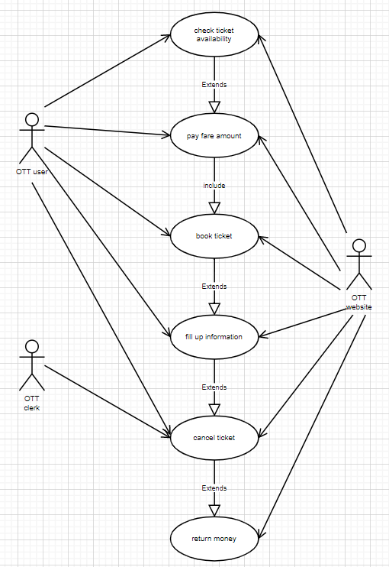

Q21. Draw usecase on E-commerce application
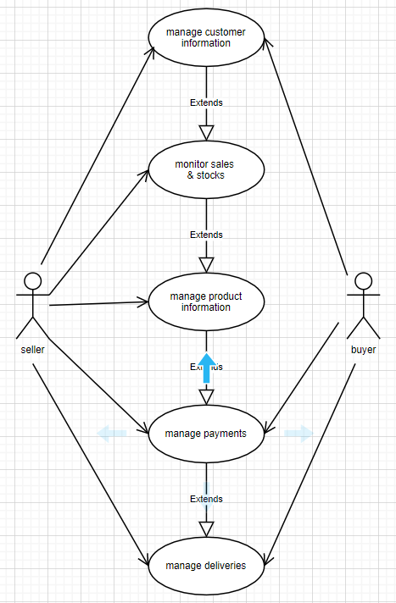

Q22. Draw usecase on Online shopping product using payment gateway.
